Welcome to 2020 -2021 Season

The
DANCE THEATRE
Performing Arts

DANCE ARTS:
TAP BALLET JAZZ HIP HOP MODERN/CONTEMPORARY STRETCH

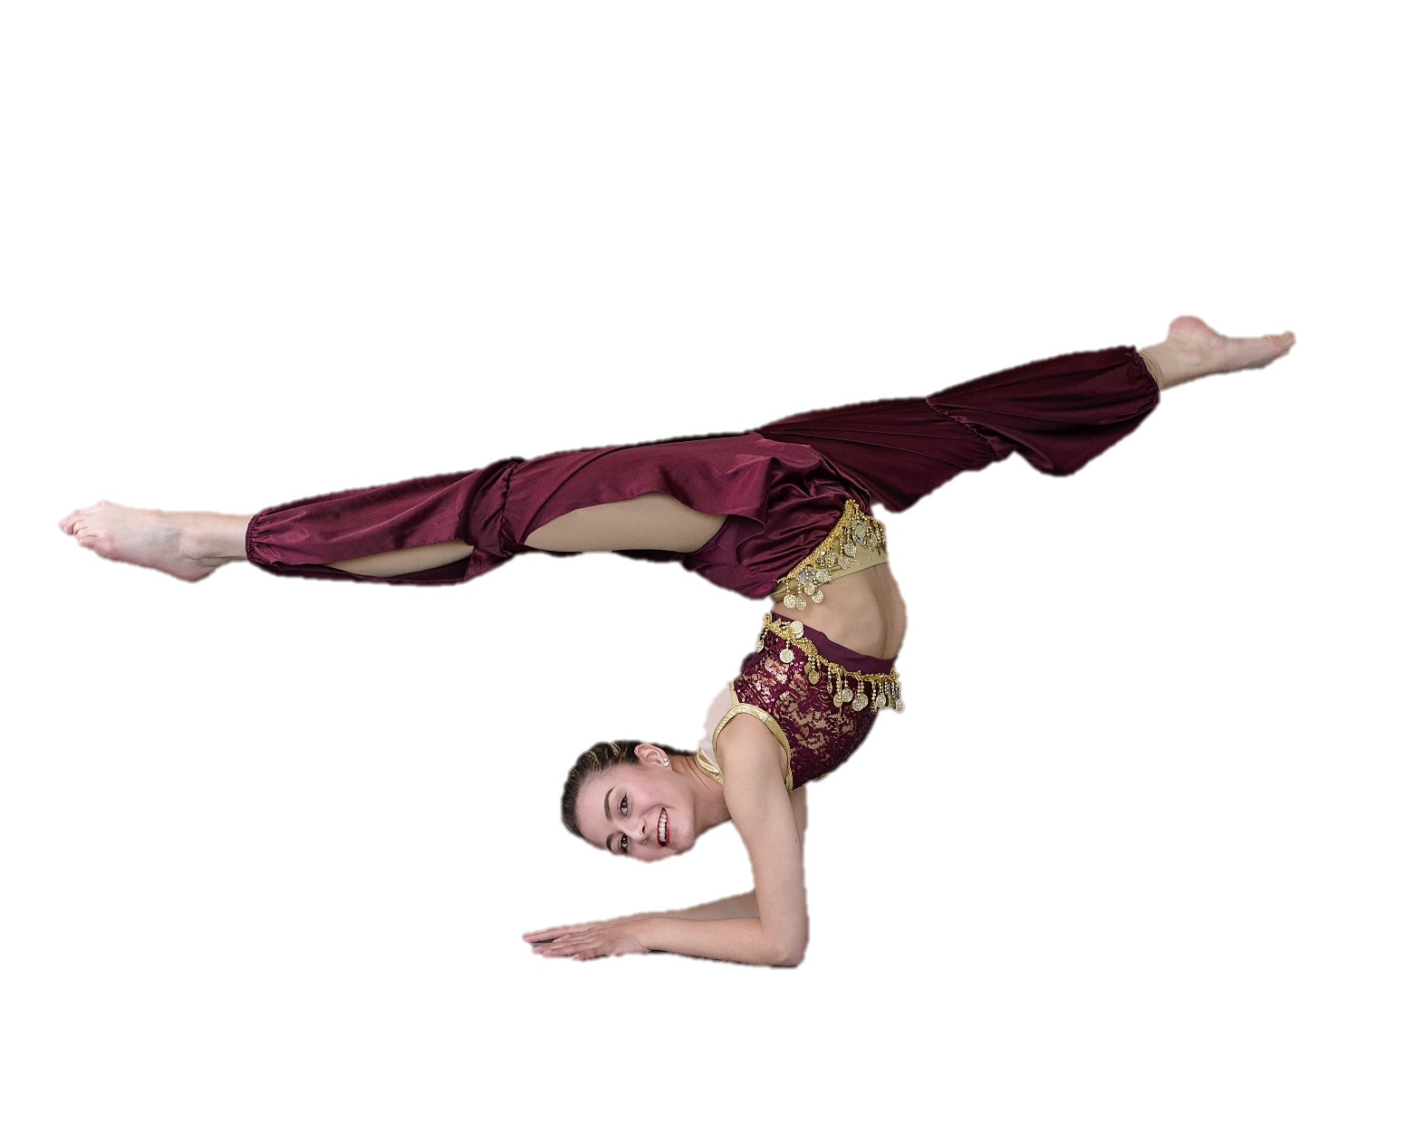
CIRCUS ARTS:
TUMBLING ACRO

THEATRTE ARTS:
DRAMA – Acting BEHIND THE STAGE –Stage Craft SINGING

ADULT CLASSES

587- 521-7069
17412 – 108 Ave
dancetheatrearts2019@gmail.com

The DANCE THEATRE
2020-21 General Program Fee Schedule
1. This is a full year program running from September 8, 2020 to June 26, 2021.
- Classes offered:
DANCE ARTS– Tap, Ballet, Jazz, Modern, Lyrical, Hip Hop, Musical Theatre,
Stretch
THEATRE ARTS – Drama, Vocal (Singing) Behind the Stage (Stage Craft) ACROBATIC ARTS – Tumbling, Acro

- Mandatory Performance Obligations include Christmas show, Year End Musical, and participation in one or two dance festivals for recreational classes. For competitive groups – Christmas show, Year End Musical Solo Show and/or Group Show, 2-4 competitions in and out of city.
- Optional performance Obligations include numerous performances for various community events and senior shows. As well as additional competitions or festivals that may or may not be out of town.
- All classes are one hour per week except Intermediate and Senior Tap, Ballet and Jazz and Behind the Stage which are 1.5 - 2 hours per week. Students enrolled in stretch may attend all stretch classes. Stretch class is mandatory for anyone registered in any Intermediate or Senior level class.

- Fees for the classes are as follows:
- One Hour Classes - $560.00 per year/ per class payable by a non-refundable pre-payment fee of $112.00 per class and monthly installments of $56.00 per month per class October 1 to May 1. The pre-payment fees are applied to your September and June installments only.

    - One and one half Hour Classes - $650.00 per year per class payable by a non-refundable prepayment fee of $130.00 upon registration and monthly installments of $65.00 per month October 1 – May 1. The pre-payment will be applied to your May and June Installments only.

    - Two Hour Classes - $720.00 per year per class payable by a non-refundable pre-payment fee of $144.00 upon registration and monthly installments of $72.00 per month September 1 – April 1. The pre-payment will be applied to your May and June Installments only.

    - Specialty Half hour classes - $280.00 per year per class payable by a non-refundable pre-payment of $40.00 and monthly installments of $28.00 per month September 1– April 1. The pre-payment will be applied to your May and June installments only.

    - Add on Classes: - These classes will run from January – April for the purpose of setting choreography for competitions. Dancers may sign-up to be part of these numbers. Dancers must attend all out of town competitions. Regular attendance is mandatory. Cost is a onetime fee of $125.00 per routine. Classes for this year are musical theatre, acro, open. Classes are not scheduled on our time table but most likely will be held on Saturdays. Costume fees will apply. These classes do not qualify for discounts.

All fees paid by monthly installment are due on or before the First (1st) of each month commencing October 1, 2020. (Fees are payable by e-transfer to dancetheatrearts2019@gmail.com, cash, or post-dated cheques. Fees paid after the 5th of the month may be subject to a $10.00 late fee. GST is included in all fees.

CLASS DISCOUNTS:.
- Year in Advance discount:
      - For students wishing to pay for the year in advance and receive a 5% discount for their classes, the following deadlines must be met. There will be no exceptions:
      - New students: pre-payment paid upon registration and the balance paid by Septembe20th.
      - Returning students: pre-payment paid by June 30 and balance paid by September 1st.
Student Loyalty Discount:
- As a thank you to returning Dance Theatre family members an additional discount will be offered to returning students who are taking a minimum of three general classes per week. (Stretch is not included) The discount will be offered as follows:
- Students entering their 3rd year will receive a 3% discount on their monthly installment fees (does not include pre-payment) or the equivalent for those paying for the year in advance.
- Students entering their 5th year will receive a 5% discount on their monthly installment fees (does not include pre-payment) or the equivalent for those paying for the year in advance.

NB: ALL SUBSIDIES AND DISCOUNTS ARE SUBJECT TO THE FAMILY BEING IN GOOD STANDING WITH THE STUDIO AND THE PARENT’S ASSOCIATION.

Dance Theatre Elite Program: For committed students who wish to maximize their training.

❖ Junior Program: (9-11 hrs per week)
- Depending on age the students will take the following 1 hour classes:
Tap, Ballet, Jazz, Modern, Lyrical, Hip Hop, Drama, Vocal, Tumbling, Acro (if meets requirements) and Stretch
- Fee for the year is $2700.00 payable by a non-refundable pre-payment of $540.00 and monthly installments of $270.00 per month October 1 – May 1. The deposit will be applied to your May and June installments only. Fees paid after the 5th of the month may be subject to a $10.00 late fee.

❖ Intermediate/ Senior Program: (13-15 hrs per week)
- Students will take the following 1 hour classes:
Modern, Lyrical, Hip Hop, Tumbling, Drama, Vocal, Acro (If meets requirements), Stretch. Students who are eligible will also take pre-pointe or pointe (1/2 or 1 hour)
- And the following 1.5 or 2 hour classes: Tap, Ballet, Jazz
- Fee for the year is $3000.00 payable by a non-refundable pre-payment of $600.00 and monthly installments of $300.00 per month October 1 – May 1. The pre-payment will be applied to your September and June installments only. Fees paid after the 5th of the month may be subject to a $10.00 late fee

For both Elite programs:
- There is no pay in advance discount for this program as fees are already discounted.
- Students must be a minimum of 7 years of age with at least one year of previous training and have received approval for this program.
- Elite program dancers are automatically part of the Competition Travel team
- Mandatory attendance is required for all studio workshops, any in city dance conventions, all regularly scheduled performances, attend up to 4 competitions/festivals including out of city events, and attend all studio and Parent Association functions.
- Students and parents must sign a commitment contract.

ADDITIONAL FEES:

Costumes:

- A costume fee of $75.00 per choreography class is due and payable to the Parent’s Association by October 1st. After that date the fee will be $110.00. Drama, Vocal and Stretch classes are exempt from this fee. Returning tumbling/acro students will be informed if they need to purchase a new costume. Fee(s) may be paid by cash, cheque, credit or debit. Note: Families with more than two costumes may arrange for a payment schedule with the Parents Association.

Competition and Convention Fees:

ALL competition entry fee and Convention fees are the responsibility of the parent and must be paid in full by the posted deadline. The Parent’s Association may subsidize these events for our students, however the type and amount of the subsidy may vary dependent upon your history of fundraising participation with the Association. It is recommended that parents consider making installments towards competition fees well in advance of the due dates. Convention and competition fees are payable to The Parents Association.

Solos and Duo/Trios: (For competitions)

- Solos:
- For new choreography, fees are $140.00 for the first solo and $110.00 for each additional solo. ▪ For repeating solos a $90.00 coaching fee will be charged.
- Duos/Trios
- Fees are $100.00 per person for the 1st routine and $85.00 for additional routines with the same partner(s).

Audition and Casting fees:

- Audition notices are regularly sent to the studio and posted on numerous Face Book pages. Often there is a fee charged by the organization holding the audition. This fee is payable directly to the organization.
- Moscow Ballet Audition – At this time the 2020 tour of the Great Russian Nutcracker has been cancelled..

In Studio Workshops:

- The Dance Theatre regularly hosts various workshop pertaining to the performing arts. Sign-up sheets will be posted at the desk. All fees charged are cost recovery. Fees must be paid for upon sign-up. There is no refund for these events and anyone signing the sheet will be invoiced even if you remove you name at a later date.
- Workshops may include flexibility, acro, drumming, African dance and drumming, partner dance (Swing, Rock m Roll) stilt walking, ballroom, Broadway Connection workshops, skipping, acting, puppet making.

LENGTH OF CLASSES:

Beginner - Junior Level - 1 hour classes
Tap, ballet, jazz, hip hop, tumbling, drama, singing, stretch
Modern-Lyrical combined (for 6-8 yrs, must be taken in conjunction with ballet and jazz classes)
Modern, (must take ballet) Lyrical (must take ballet and jazz)
Acro (Must be registered in tumbling class)

Intermediate Level Classes
Tap, Jazz Ballet, Tumbling – 90 minute classes (1 hour technique, 30 minutes choreography)
Modern, Lyrical, Hip Hop, Acro – 60 minute classes
Pre-pointe – 30 minute classes (Must have teacher recommendation) Pointe – 60 minute classes (Must have teacher recommendation)

Senior Level Classes
Tap, Jazz, Tumbling – 90 minute classes (60 minutes technique, 30 minutes choreography)
Ballet – 120 minute classes (90 minutes technique, 30 minutes choreography) Modern, Lyrical, Hip Hop, Tumbling, Acro, Pointe – 60 minute classes

Behind the Stage
This class will run in three 3 month components in the areas of stage management, design, and directing. The final month will be participation in our year end production.
Add-on Classes
Depending on the style, groupings and number of routines being set these classes will run between
1 – 2 hours each. Classes may run weekly or bi-weekly for the three month term).These routines will travel to all competitions.

FOR FURTHER INFORMATION CHECK OUT OUR WEBSITE AT:
www.edmdancetheatre.com

CALL THE STUDIO AT:

587-521-7069

EMAIL TO:

dancetheatrearts2019@gmail.co,

Dancewear List – 2020-21

Pre-school Classes:
- Ballet slippers – Bloch Dansoft Pink (girls) black (boys) SO205
- Tap shoes – Capezio tan tap (girls) 625 Black boys Capezio tap (Beginners do not need shoes until January)
- Body suit – any color, style (girls)
- Black stretch pants, fitted t-shirt (boys)
- Tights for girls white or pink preferred, dance tights not necessary
- For performances only – caramel colored tights

Ballet classes:
- Pink ballet slippers – style your preference (boys – black)
- Black camisole style body suit (girls)
- Mondor ballet pink tights 310
- Hair nets/bun cover if desired
- Boys – white fitted t-shirt, black yoga style shorts or tights

Tap, Jazz, Modern, Lyrical, Musical Theatre (Dance) Classes:
- Body suit, tights any style or color
- Spandex shorts and yoga/ bra tops if allowed by teacher
- Convertible tights recommended for students taking modern
- Tap shoes – Bloch Showstopper – tan – 12 & over get higher heel. Int/Sr tan slip on tap shoes. Some senior classes will wear black tie up shoes
- Tap shoes – boys – black boy shoes tie or slip on
- Jazz tan Bloch Elasta bootie SO499 (note intermediate & senior classes may need black as well)
- Lyrical – tan jazz shoes required, toe undies may be worn in class but must have shoes
-  Modern – bare feet
- Musical Theatre – Sr’s may need tan character shoes

Acro, Tumbling:
- Good fitting bodysuit, spandex shorts may be worn over top
- Bare legs with either gymnastic slippers or grippy socks
- Boys – fitted shorts or gymnastic leggings, fitted tank top, bare feet

Hip Hop Classes:
- Loose clothing – not overly baggie, must be able to move. Absolutely no jeans.
- Solid white runners
Drama & Musical Theatre (Voice) Classes:
- Comfortable clothing

All students will need a pair of cotton stretch black dance pants and all black stretch shorts. Pants can be purchased at dance shops & Walmart. Female dancers will need caramel colored tights for performance – Mondor KR. Note that these are the performance tights that are more expensive and run easier. Do not use the good tights for class time. Boys need long black socks for competition.

RECOMMENDED DANCE SUPPLIERS

The following dance shops are ones that we know will carry the dancewear and costume accessories that our dance students will need.

Karries Kostumes - 2001 Tuder Glen, St. Albert (take 170 St. to Save – on –Foods on left, Karries is in the strip mall on your right
- All dance wear - body suits, tights, shoes
- Required hair pieces loose curl pony tail, and/or curly bun twist. Your teacher will let you know what is required.
- Stage make-up if required
- Wigs if required

All 4 Dance – 11054 – 156 Street
- All dance wear – body suits, tights, shoes

BZ Bodies – 6 – 220 Century Rd, Spruce Grove (take Stony Plain Rd west to Spruce Grove, turn right on Century Rd, past church on right hand side)
- All dance wear – body suits, tights, shoes
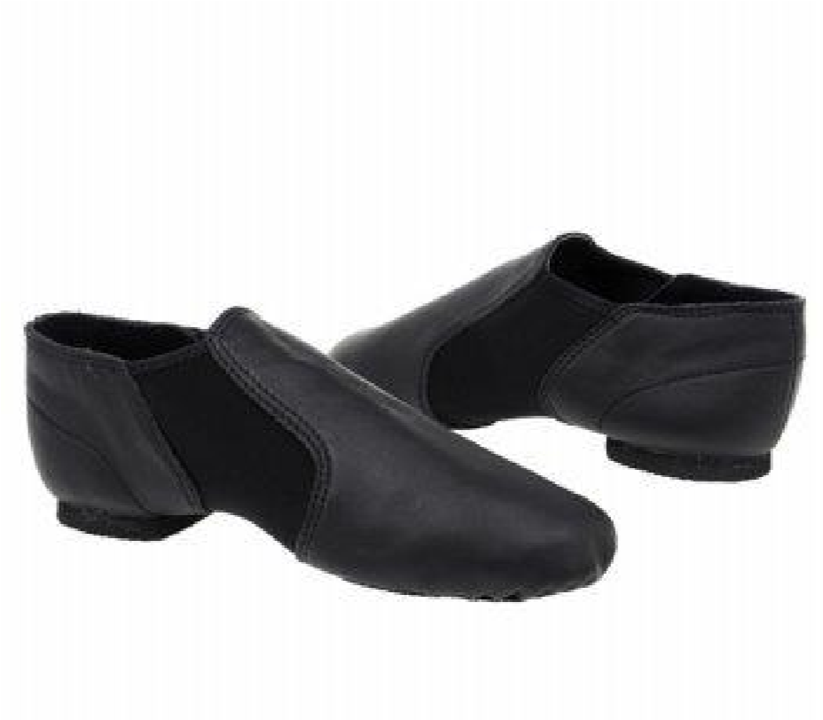
All male students must have black socks for performances.

On Stage – 10004 – 79 Ave
- All dancewear - bodysuits, tights, shoes
- Provides excellent fitting for pointe shoes

Adagio – Castle Downs Rd and153 Ave (Mall across from Rec centre)
- All dance wear – body suits, tights, shoes

Body suits and tights can be purchased at Walmart and occasionally The Bay, and other department stores. The quality may vary and colors and sizes are generally limited. DO NOT purchase dance shoes anywhere but at a recommended dance shop.

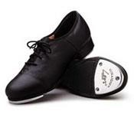
All female students will need caramel colored tights for performance wear. These should not be used for class. Ballet students will need ballet pink tights for performance and a different pair for class.

The DANCE THEATRE

2020– 2021 Registration

Please print legibly

STUDENT’S NAME: _______________________________ HOME PHONE: __________________

ADDRESS: ______________________________________ P.C._____________

E-MAIL: _____________________________

BIRTHDATE: DAY: _____ MONTH:_______ YEAR: _______ AGE: _____

MOTHER ________________ CELL: _______ FATHER::_______________ CELL: __________

All general program classes are 1 hour per week except for Intermediate and Senior level tap, ballet and jazz classes which are 1.5 or 2 hours – 1 – 1.5 hour technique & 0.5 hour choreography.
NB: Stretch is mandatory for all dancers attending an Intermediate and up level class

Please check desired classes

 | TAP – Beg/Jr |  | BALLET – Beg/Jr 1 |  | JAZZ – Beg/Jr 1 |  | HIP HOP- Beg/Jr 1
 | TAP – Jr 2 |  | BALLET – Jr 2 |  | JAZZ – Jr 2 |  | HIP HOP – Jr
 | TAP – Jr 3 |  | BALLET – Jr 3 |  | JAZZ – Jr 3 |  | HIP HOP – Int
 | TAP – Int 1 |  | BALLET – Int 1-2 |  | JAZZ – Int 1 |  | HIP HOP - Sr
 | TAP – Int 2 |  | BALLET – Sr 1/2 |  | JAZZ – Int 2 |  | LYRICAL - Jr
 | TAP –Int 3 |  | BALLET – Sr 3/4 |  | JAZZ – Int 3 |  | LYRICAL – Int
 | TAP - Sr 1 |  | TEEN BALLLET |  | JAZZ – Sr 1/2 |  | LYRICAL – Sr
 | TAP – Sr 4 |  | PRE-POINT (Permission  required) |  | JAZZ – Sr 3/4 |  | MODERN- LYRICAL  6-8 YRS
 | STRETCH |  | POINTE (Permission  required) |  | TUMBLING – Beg/Jr  6-8 |  | MODERN – Jr
 | VOCAL – Beg/Jr |  | DRAMA –Beg/ Jr/Int |  | TUMBLING  Beg/Jr 9-12 |  | MODERN – Int
 | )VOCAL – Int/Sr |  | DRAMA - Sr |  | TUMBLING – Int/Sr |  | MODERN – Sr
 | BEHIND THE STAGE |  | ELITE - Jr  (Permission required |  | ELITE – Sr  (Permission required

See back to work out your fees

I acknowledge that I will receive a student handbook and will read it to fully understand my obligations and agree to abide by all the policies of the Dance Theatre and its agents. I further understand that any relevant information contained in this form will be used by the Dance Theatre for the purpose of completing registration and/or entry forms for the various competitions, festivals, conventions, workshops and other events that my child is able to attend. I consent to receive e-mail from the Dance Theatre and the Parent’s Association.

Parent’s Signature ________________________________ Date________________

Work out your Fees: Note: Mandatory stretch is free to those taking a minimum of 3 (Ballet must be one) dance/tumbling/acro classes.

Prepayment (Non-refundable. Applied to September and June installments only) GST is included in all fees
Length of class | Pre-payment required | X Number of Classes | = Amount Due
0.5 hour | $56.00
1 hour class | $112.00
1.5 hour class | $130.00
2 hour class | $144.00
Jr Elite | $520.00 | NA
Int - Sr Elite | $560.00
TOTAL PRE-PAYMENT DUE WITH REGISTRATION

Monthly fee payment (Due on the 1st of the month – October – May)
Length of class | Monthly payment | X Number of Classes | = Amount Due
0.5 hour | $28.00
1 hour class | $56.00
1.5 hour class | $65.00
2 hour class | $72.00
Jr Elite | $260.00
Int – Sr Elite | $280.00
TOTAL MONTHLY PAYMENT

METHOD OF PAYMENT: please check

NOTE: due to contractual obligations all fees are non-refundable. A one month’s notice of withdrawal from classes must be given by the first of the last month of class to avoid penalty. (see handbook for more information). Should a student fail to complete the year the balance
of the yearly tuition will become due and payable immediately.

Parents are responsible for additional costs of costumes, workshops, field trips, competition entry fees (all students will participate in at least one mandatory festival -Rising Stars!) and tuition for solos,
duos & trios.

YEAR’S TUITION PAID IN ADVANCE : (5% discount in fees for General program – Elite not included - IF deadlines are met – NO EXCEPTIONS). *Returning students - pre-payment paid by June 30th, 2020 and balance paid by September 1,2020, *New students - pre-payment deposit paid upon registration and balance paid by Sept. 20, 2020
PRE-PAYMENT OF _________ WITH BALANCE of ___________

MONTHLY INSTALLMENTS
PRE-PAYMENT OF _________ WITH MONTH October 1,2020 to May 1, 2021. Payable by post-dated cheque, or e-transfer to dancetheatrearts2019@gmail.com

A $10.00 late fee will be applied after the 5th of the month unless prior arrangements have been made.

Add –on classes must be registered and paid for by October 15th. Payment must be made in full unless arrangements have been made with the office. Discounts do not apply to these classes. Office will adjust monthly fees payment schedule for any applicable subsidies and scholarships and discounts.

