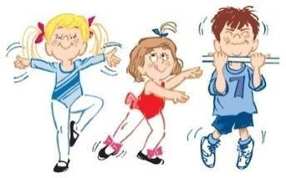
^{The} Dance Theatre
Performing Arts
Pre-school Programs
FULL SEASON PROGRAMS:

PRE-SCHOOL DANCE: FULL SEASON (September – June)
- Combination class of tap, ballet, jazz, with intro to hip hop, tumbling, rhythmic gymnastics at age appropriate levels, acting skills and rhythm games.
- For ages 2 – 5 years (pre grade 1)
- 45 minute class per week
- Students are expected to participate in the Christmas Show, Year End Musical, and a minimum of one dance festival (Rising Stars!)
- Fee - $450.00 for the year payable by a non-refundable pre-payment of $90.00 and monthly installments of $45.00 due on the first of the month September – May. The pre-payment will be applied to your April, May and June installments providing the season is completed.
.
Full season students wishing to pay for the year in advance and receive a 5% discount, must meet the following deadlines. There will be no exceptions.

New students: pre-payment paid upon registration and balance paid in full by September 20th. Returning students: deposit paid by June 30th, and balance paid by September 1st.

All fees (except costume fees) are payable by e-transfer to dancetheatrearts2019@gmail.com, cash or cheque,.

If you are applying for funding from Kidsport, Jumpstart, or other organization, you will be responsible for any fees due until we receive funding. Please let the office know if you have applied or are planning to do so.

ADDITIONAL FEES:

Costume Fee of $75.00 is due and payable to the Parent’s Association by October 1st. After that date the fee will be $110.00. Costume fees are payable to E.C.D.T.P.A. by e-transfer to ecdtpa@gmail.com or by cheque payable to E.C.D.T.P.A.,.
Competition Fees:
ALL entry fees are the responsibility of the parent and must be paid in full by the posted deadline. Convention fees must be paid by the posted deadline. The Parent’s Association may subsidize these events for our students, however the amount of the subsidy may vary dependent upon your history of fundraising participation with the Association. Competition fees are payable to the Parent’s Association by e-transfer to ecdtpa@gmail.com, cheque

FALL, WINTER, SPRING SESSIONAL PROGRAMS:

PRE-SCHOOL DANCE: SESSIONAL PROGRAMS (September 7 – November 23, January
4 – March 21, March 28 – June 13)
- Combination class of jazz, ballet, creative movement and rhythm games.
  - 45 minute class per week for 12 weeks. There are no performance or costume obligations
  - Fee per session is $150.00 non-refundable after start date.

MOM AND ME: SESSIONAL PROGRAMS (September 8 – November 10, January 5 –
March 9, April 6 – June 8)
- For children 16 – 30 months using movement, songs, games, props and beginning dance steps
  - ½ hour class per week
  - Fee per session is $65.00 for 10 weeks – non-refundable after start date.

PRE-SCHOOL TUMBLING: SESSIONAL PROGRAMS (September 8 – November 24,
January 5 – March 22, April 5 – June 14)
- 45 minute class per week for 12 weeks No performance or costume obligations.
-  Fee per session is $150 non-refundable after start date.

PRE-SCHOOL RHYTHMIC GYMNASTICS: SESSIONAL PROGRAMS (Same dates as tumbling)
- Introduction to use of rhythmic equipment such as ribbons, balls, hoops, with basic tumbling and movement skills
- 45 minute class per week for 12 weeks
- No performance or costume obligations
- Fee per session is $150 non-refundable after start date

All fees are payable by e-transfer to dancetheatrearts2019@gmail.com, cash or cheque,

Students who register for fall, winter and spring sessions( in one program) and wish to pay for all three in advance will receive a 5% discount on the total fee.

CLASS SCHEDULE:

Our tentative pre-school schedule is as follows:
Full season dance: Monday – 6:00pm Advanced 4 – 5 yrs
Saturday - 9:00 am Beginner – 2-3 yrs
9:00 am – Beginner 4-5 yrs
Sessional Pre-school Dance: Saturday – 9:00 am Sessional
Mom and Me: Saturday - 10:30 am
Sessional Tumbling: Saturday – 11:00 am – 2-3 yrs (Parents may need to assist)
11:45 am – 4-5 yrs
NOTE: Morning or afternoon weekday classes may be added to the schedule on demand.

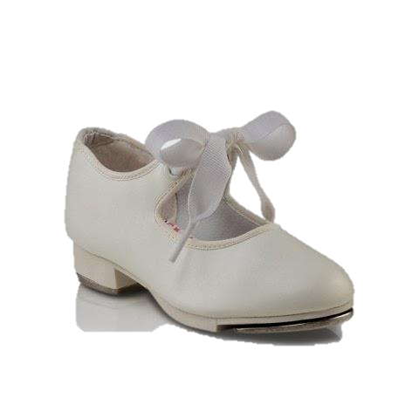
Dancewear List – 2020-21

PRE-SCHOOL DANCE- FULL SEASON CLASSES:

- Ballet slippers – Bloch Dansoft Pink (girls) black (boys) SO205
- Tap shoes – Capezio tan tap (girls) 625 Black boys Capezio tap (Beginners do not need shoes until
January)
- Body suit – any color, style (girls)
- Black stretch pants, fitted t-shirt (boys)
- Tights for girls white or pink preferred, dance tights not necessary
- For performances only – caramel colored tights -girls
- Black socks – boys

SESSIONAL CLASSES:

- Girls Dance: Body suit and tights or shorts and fitted top with tights in winter, leggings and fitted shirt
- Boys Dance: Pants or sweats or shorts, fitted t-shirt
- Dance shoes not necessary but ballet slippers are suggested
- Tumbling classes: fitted shorts and t-shirts, girls can wear body suits, bare legs and grippy socks or Gymnastic slippers
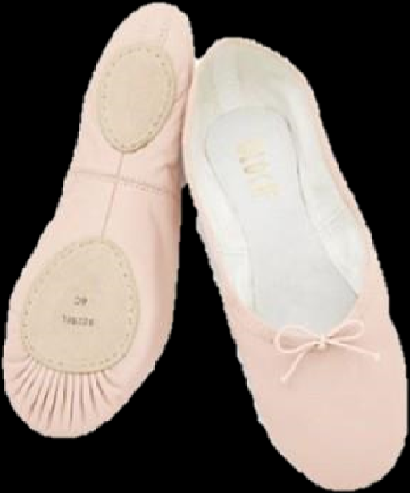

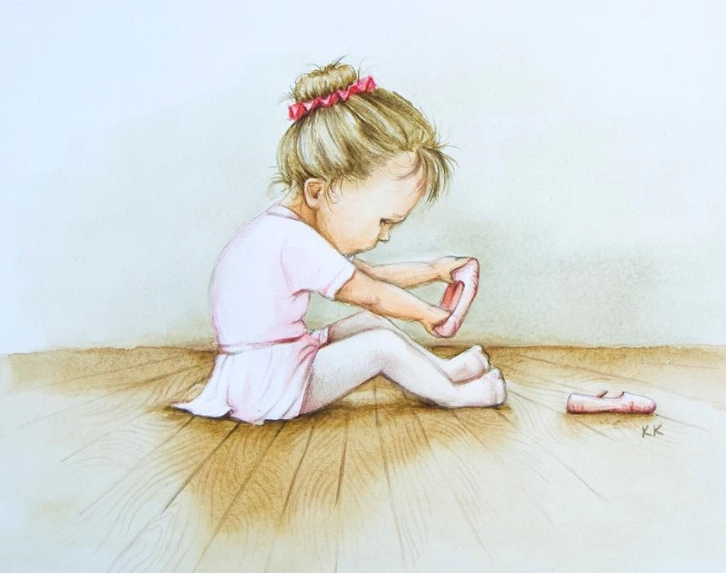

Recommended Dance Suppliers

The following dance shops are ones that we know will carry the dancewear and costume accessories that our dance students will need.

Karries Kostumes - 2001 Tuder Glen, St. Albert (take 170 St. to Save – on –Foods on left, Karries is in the strip mall on your right
- All dance wear - body suits, tights, shoes
- Required hair pieces or loose curl pony tail, and/or curly bun twist. Your teacher will let you know what is required.
- Stage make-up if required
- Wigs if required

All 4 Dance – 163 St & 111 Ave (around corner from Princess auto) All dance wear – body suits, tights, shoes

BZ Bodies – 6 – 220 Century Rd, Spruce Grove (take Stony Plain Rd west to Spruce Grove, turn right on Century Rd, past church on right hand side)
- All dance wear – body suits, tights, shoes

On Stage – 10004 – 79 Ave
- All dancewear - bodysuits, tights, shoes
- Provides excellent fitting for pointe shoes

Adagio – Castle Downs Rd and153 Ave (Mall across from Rec centre) All dance wear – body suits, tights, shoes

Body suits and tights can be purchased at Walmart and occasionally The Bay, and other department stores. The quality may vary and colors and sizes
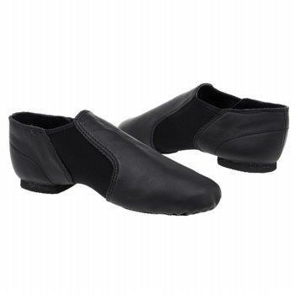
are generally limited. DO NOT purchase dance shoes anywhere but at a recommended dance shop. All female students will need caramel colored tights for performance wear. These should not be used for class. Ballet students will need ballet pink tights for performance and a different pair for class. All male students must have black socks for performances.

^{The} Dance Theatre’s

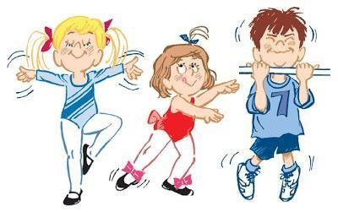
2020– 2021 Pre-school Registration

STUDENT’S NAME: ___________________________________________________________________

ADDRESS: _____________________________________________________ P.C. _______________

HOME PHONE: __________________ E-MAIL: _____________________________

BIRTHDATE: DAY: ________ MONTH:_______ YEAR:_______ AGE: _____

MOTHER ___________________ CELL: __________ FATHER::___________________ CELL: __________

COURSES SELECTED: - Please check

ALL PRE-SCHOOL CLASSES ARE 45 MINUTES PER WEEK (except the spring sessional classes which are 54minutes per week.) MOM AND ME ARE 30 MINUTES PER WEEK.

_____ PRE-SCHOOL DANCE – Full Year

_____ PRE-SCHOOL DANCE – Sessional ____Fall ____Winter ____Spring

_____ PRE-SCHOOL TUMBLING – Sessional ____Fall ____Winter ____Spring

_____ PRE-SCHOOL RHYTHMIC GYMNASTICS –Sessional ____Fall ____Winter ____Spring

_____ MOM & ME – Sessional ____Fall ____Winter ____Spring

See back to work out your fees.

Note: Due to contractual obligations ALL FEES ARE NON-REFUNDABLE. A one month’s notice of withdrawal from full year classes must be given by the first of the last month of class to avoid penalty. (see handbook for more information). Should a student fail to complete the year the balance of the yearly tuition will become due
and payable immediately.
Additional costs for costumes, workshops, field trips, and tuition for solos, duos & trios are the parent’s
responsibility.
Sessional classes are payable in full upon registration. There is no refund after classes commence |  |  | .

I acknowledge that I will receive a student handbook and will read to fully understand my obligations and agree to abide by all the policies of the The Dance Theatre Performing Arts. and its agents. I further understand that any relevant information contained in this form will be used by the Dance Theatre for the purpose of completing registration and/or entry forms for the various competitions, festivals, conventions, workshops and other events that my child is able to attend. I consent to receive email from the Dance Theatre and the Parent’s Association.

Parent’s Signature ________________________________ Date________________

Work out your fees:

PRE-SCHOOL DANCE – FULL YEAR

Note: If you are applying for funding from Kidsport, Jumpstart or any other organization, you will be responsible for any fees due up until we receive the funding. Please let the office know if you have applied or are planning to do so.

TOTAL FEE - $450.00

PRE-PAYMENT __$90__ Applied to September and June installments only.

MONTHLY INSTALLMENTS of $45.00 –on or before October 1, 2020 – May 1, 2021 payable by e-transfer, cash, cheque, A $10.00 late fee will be applied after the 5th of the month.

OR RECEIVE A 5% DISCOUNT BY PAYING THE YEAR IN FULL

PRE-PAYMENT $90.00

BALANCE OF $300.00_ PAID IN FULL BY
Returning students September 1, 2020 or
New students September 20^{th,,} 2020

All fees payable by e-transfer (preferred) to dancetheatrearts2019@gmail.com, by cheque payable to Dance Theatre Performing Arts or cash

12 WEEK SESSIONAL CLASSES: FALL WINTER SPRING

CLASS | SESSION |  |  | NUMBER OF SESSIONS | X FEE | = FEE  DUE
 | FALL | WINTER | SPRING
MOM & ME |  |  |  |  | $65.00
DANCE |  |  |  |  | $150.00
TUMBLING 2-3 yrs |  |  |  |  | $150.00
TUMBLING 4-5 yrs |  |  |  |  | $150.00
RHYTHMIC GYMNASTIC |  |  |  |  | $150.00
TOTAL FEE
DUE

REGISTER AND PAY FOR ALL THREE SESSIONS (FALL WINTER, SPRING) OF A CLASS IN FULL BY SEPTEMBER 20TH, 2020 AND RECEIVE A 5% DISCOUNT IN TOTAL FEES.

